# chapter1

* current state of IT project management
  + 1940s first electronic computer
  + 50s-60s EDP Era
    - mainframes, automating organizational transactions (accounting, inventory mgmt.)
    - goal: improve efficiency and reduce costs
    - problems: systems don't talk to each other
    - IT projects are structured, long terms, requirements are stable
  + 70s-80s PC Era
    - personal computers
    - problems: security, data integrity, maintenance, and sharing of data
    - IT projects are shorter, cross functional
  + 90s-20s Network Era
    - networked computers
    - goal: creating an IT infrastructure to support partners, vendors and customers
    - problem: how to support new business model and strategy
    - IT projects require scalability
  + 2000s+ Globalization
    - work with anyone in anywhere at anytime
    - IT projects are dynamic, geographically dispersed, and culturally diverse
    - IT project mgmt. becomes more challenging and rewarding than previous eras
* how successfully managing IT projects remains a challenge for most organizations.
  + larger projects have the lowest success rate and are more riskier than medium & smaller projects
  + technology, business models, and markets change too rapidly
* value-driven approach
  + IT projects must provide value to the organization
  + e.g.: better customer service, more efficient business processes, lower costs, expanded market share
  + the project success should be measured by value, not by budget/schedule
* socio-technical approach
  + IT professionals must understand the business
  + the customers/clients must become stakeholders in the project
  + you cannot rely solely on the technical side of IT, you must understand the impact technology will have on business & organizational processes
* project management approach
  + applying PM methodology
    - Defining processes, controls, tools, standards and deliverables across the entire organization
    - step by step activities, processes, tools, quality standards, controls and deliverables that are defined for the entire project
  + resources could be better allocated and controlled
  + expectations could be better communicated and managed
  + competition could be encouraged
  + efficiency and effectiveness could be achieved
* knowledge management approach
  + lessons learned, best practices & shared knowledge
  + a systematic process for acquiring, creating, synthesizing, sharing and using information, insights and experiences to transform ideas into bus9ness value
* Define what a project is and describe its attributes.
  + project: a temporary endeavor undertaken to create a unique product, service or result
  + attributes: time frame, purpose (to provide value), owner and sponsor, resources (the triple constraint) roles (pm, sponsor, SME, TE technical experts), risks & assumptions, interdependent tasks, organizational change, operate in environments larger than the project itself
* Define the discipline called project management.
  + PM: the application of knowledge, skills, tools and techniques to project activities to meet project requirements, including:
    - identifying requirements
    - establishing clear and achievable objectives
    - balancing the competing demands for quality, scope, time and cost
    - adapting the specifications, plans, and approaches to the different concerns and expectations of the various stakeholders
* Define Triple Constraint
  + scope, schedule & budget
  + determines the project goal & expectations
* Identify the Project Management Body of Knowledge (PMBOK®) core knowledge areas.
  + project procurement management
  + project integration management
  + project scope management
  + project time management
  + project cost management
  + project quality management
  + project HR management
  + project communications management
  + project risk management

# chapter 2

* Describe the project life cycle (PLC) & identify the phases & infrastructure that make up the It
  + collection of logical stages/phases that maps the life of a project from its beginning to define, build, and deliver the product
  + each phase should provide one or more deliverables
  + define project goal, conceptualize & initialize project > develop project plan & charter > execute & control project plan > close project > evaluate project
  + Project goal: focused on providing business value to the organization; provides a clear focus and drives the other phases of the project; determines how what 'success' means for the project given the right amount of time, money and resources invested
    - deliverable: business case
  + project plan: defines the agreed upon scope, schedule and budget
    - deliverable: project charter
    - deliverable: project plan
  + Execution: manage the project scope, schedule, budget and people to ensure the project achieves its goal
    - SDLC starts & ends in the execution phase
      * deliverable: information system
  + close project: ensures that all of the work is completed as planned; deliver final project report and presentation to the client
    - deliverable: final project report
    - deliverable: project presentation
  + evaluate project: lessons learned to determine those things to do the same and those things to change; evaluate team member performance
    - deliverable: project evaluations
    - deliverable: lessons learned
* describe the systems development life cycle (SDLC)
  + planning > analysis > design > implementation > maintenance and support
  + planning : identifying and responding to a problem/opportunity; ensures the goal, scope, budget, schedule, technology and system development processes, methods and tools are in place
  + analysis: documents the specific need and requirements for a new system
  + design: uses the requirements and 'to be' logical models to design the architecture to support the new information system; includes designing the network, hardware configuration, databases, user interface and application projects
  + implementation: the development of the system, testing and installation
  + maintenance and support: the system is updated to respond to bugs, new features or to adjust to a changing business environment
* Identify the phases and infrastructure that make up the IT project methodology.
  + conceptualize & initialize project > develop project plan & charter > execute & control project, start & complete SDLC> close project > evaluate project
  + IT project management foundation
    - PM processes: initiating, planning, executing, controlling, closing
    - PM objectives: scope schedule, budget, quality
    - tools : project management, information systems development
    - infrastructure: organizational, project, technical
    - PMBOK areas: integration management, scope management, time management, cost management, quality management, HR management, communications management, risk management, procurement management
  + phase exits:
  + stage gates:
  + kill points:
  + fast tracking: starting the next phase of a project before approval is obtained for the current phase; used to reduce the project schedule; risky
* Understand and Develop a project’s measurable organizational value (MOV).
  + must be measurable, provide value to the organization, agreed upon by stakeholders, align with the organization's strategy and goals
  + identify the desired area of impact: strategic, customer, financial, operational, social
  + identify the organizational value: better, faster, cheaper, growth
  + develop an appropriate metric: money, percentage, numeric values
  + set a time frame for achieving the MOV
  + finish the sentence:
    - the project will be successful if…..
  + or develop a table
    - year 1: X increase (more $)
    - year 2: Y decrease (less cost
    - etc
* Understand what is a business case.
  + an analysis of the organizational value, feasibility, costs, benefits and risk of the project plan
  + details all possible impacts, costs and benefits
* Understand how to calculate ROI and NPV.
  + 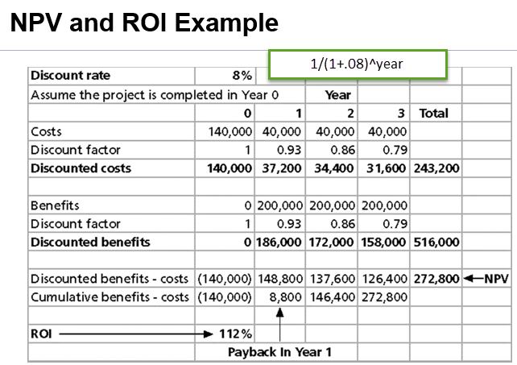
  + Discount factor: 1/(1+discount rate)^year
  + ROI: subtract project costs from project benefits, then dividing by costs
    - (total discounted benefits - total discounted costs) / discounted costs
    - higher ROIs == better
  + payback period: the amount of time it will take to recoup, in the form of net cash inflows, the total dollars invested in a project
* Understand Weighted Scoring Model
  + provides a systematic process for selecting projects based on many criteria weighted by the criteria's importance
  + the sum of all weights must total 100%
  + assign scores to each criterion for each project
  + multiply scores by weights then sum to get the total weighted scores

# chapter 3

* Define project integration management
  + entails making choices about resource allocation and making trade-offs among competing objectives and alternatives and managing the interdependencies among the project management knowledge areas
  + develop project charter > develop project management plan > direct and manage project execution > monitory and control project work > perform integrated change control > close project/phase
* describe project integration management's role in project planning, execution, and change control.
* Describe the five project management processes
  + conceptualize and initialize
    - deliverable: business case
  + develop project charter and plan
    - deliverable: project charter
    - deliverable: project plan
  + execute and control project
    - start & end SDLC
    - deliverable: information system
  + close project
    - deliverable: final project report
    - deliverable : final project presentation
  + evaluate project success
    - deliverable: evaluations
    - deliverable: lessons learned
* Understand product-oriented processes and how they are used to implement the Systems Development Life Cycle (SDLC).
  + defines how the systems development life cycle will be implemented
  + will define all of the sub-phases and deliverables associated with the execute and control project management life cycle phase
* Understand how to develop a project charter
  + serves as an agreement or contract between the project sponsor and team; provides a framework for project governance
  + project ID > project stakeholders > project description > MOV > project scope > project schedule summary > project budget summary > quality issues/standards/requirements > resources > assumptions and risks > project administration > acceptance and approval > references > terminology (acronyms and definitions)
* Identify the steps in the project planning framework
  + MOV: measurable, in a certain time frame, agreed upon; can be a sentence or table
  + scope: what's included & what is not included
    - initiation > planning > definition > verification > change control
  + phases: each project phase should define deliverables and milestones
  + tasks require a sequence, resources, time estimates
    - tasks: activity/unit of work to be completed
    - sequence: tasks maybe linear/parallel
    - resources: technology, people, and their associated cost
  + schedule & budget: the baseline plan
* how the project’s measurable organizational value (MOV) is linked to the project’s scope, schedule, and budget.
* structured approaches:
  + waterfall method: stresses a sequential and logical flow of software development activities; suitable for large & complex systems
  + requirement gathering & analysis > system design > implementation > testing > deployment of system > maintenance
* iterative approaches
  + RAD: rapid application development: compress the analysis, design, build and test activities of the SDLC into a series of short iterations or development cycles
  + prototyping: developed to discover/refine system requirement specifications; e.g. a nonfunctional/partially functional user interface to help understand the user requirement
  + spiral development: breaks up a software project into a number of mini-projects that address one/more major risks
    - identifies new risks as each iteration is completed
  + agile systems development: releases are developed through several iteration, each working release is transferred to users
    - SCRUM
    - DSDM: dynamic systems development method
    - ASD: adaptive software development
    - XP: eXtreme programming

# chapter 5

* Identify the five processes that support project scope management.
  + collect requirements: defining and documenting the customer, sponsor, or stakeholder needs and expectations
  + define scope: a detailed description of the product, service or information system to be designed, built and implemented
    - defines what work will and will not be part of the project and will serve as a basis for all future project decisions
  + create work breakdown structure: the decomposition or dividing the project deliverables into smaller and more management components
  + verify scope: confirmation and formal acceptance that the project's scope 9is accurate, complete, and supports the project's MOV
  + control scope: ensuring that controls are in place to manage proposed scope changes
* Describe the difference between product scope and project scope.
  + project oriented deliverables: support the project management and IT development processes defined in the information technology project methodology
    - tools:
      * DDT: deliverable definition table
      * DSC: deliverable structure chart
  + product oriented deliverables: specific features and functionality of the application system
    - tools
      * DFD: context dataflow diagram
      * UCD: use case diagram
* Apply several tools and techniques for defining and managing the project’s scope.
  + scope boundary: work within the scope boundary must support the project's MOV
    - work outside of the project scope do not support the project's MOV
  + scope statement: narrative description of the product, service or information system
    - for internal project's this is tied to the business need
    - for external projects this would include specifications, quantities, quality standards, and performance requirements for prospective bidders
  + scope grope: inability to define
  + scope creep: increasing featurism
  + scope leap: fundamental change
  + Scope change request form
  + scope change request log
  + deliverable definition table
    - 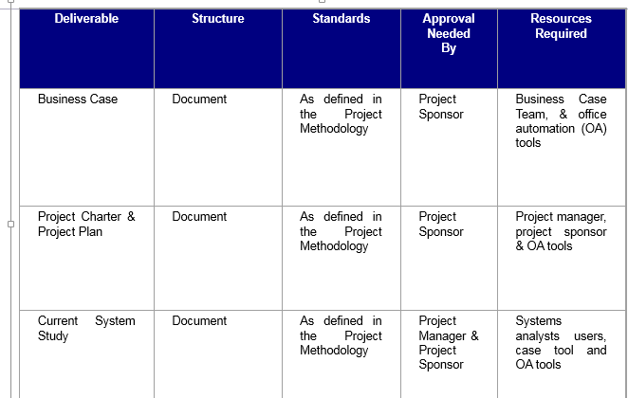
  + deliverable structure chart
    - 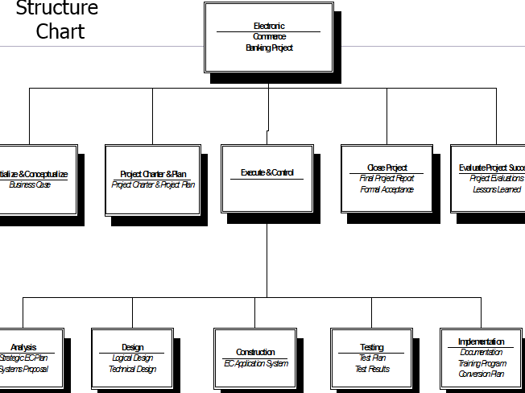
  + context level data flow diagram
    - 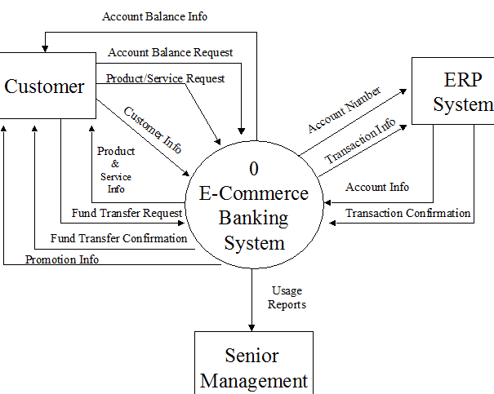
  + use case diagram
    - 